1. Used to Iterator over elements.
2. Used in LHS to iterate over input fields.
3. Consider it as for loop.
4. 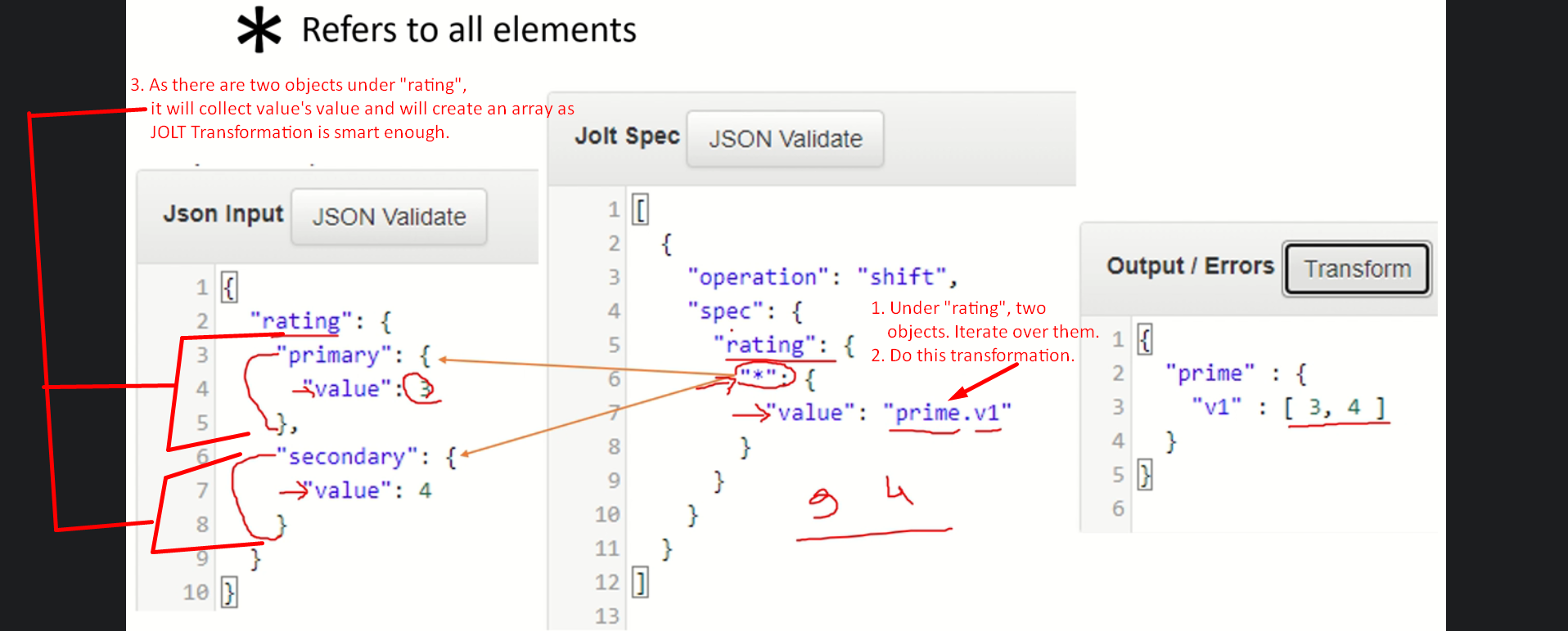
5. & we discussed in previous lecture. 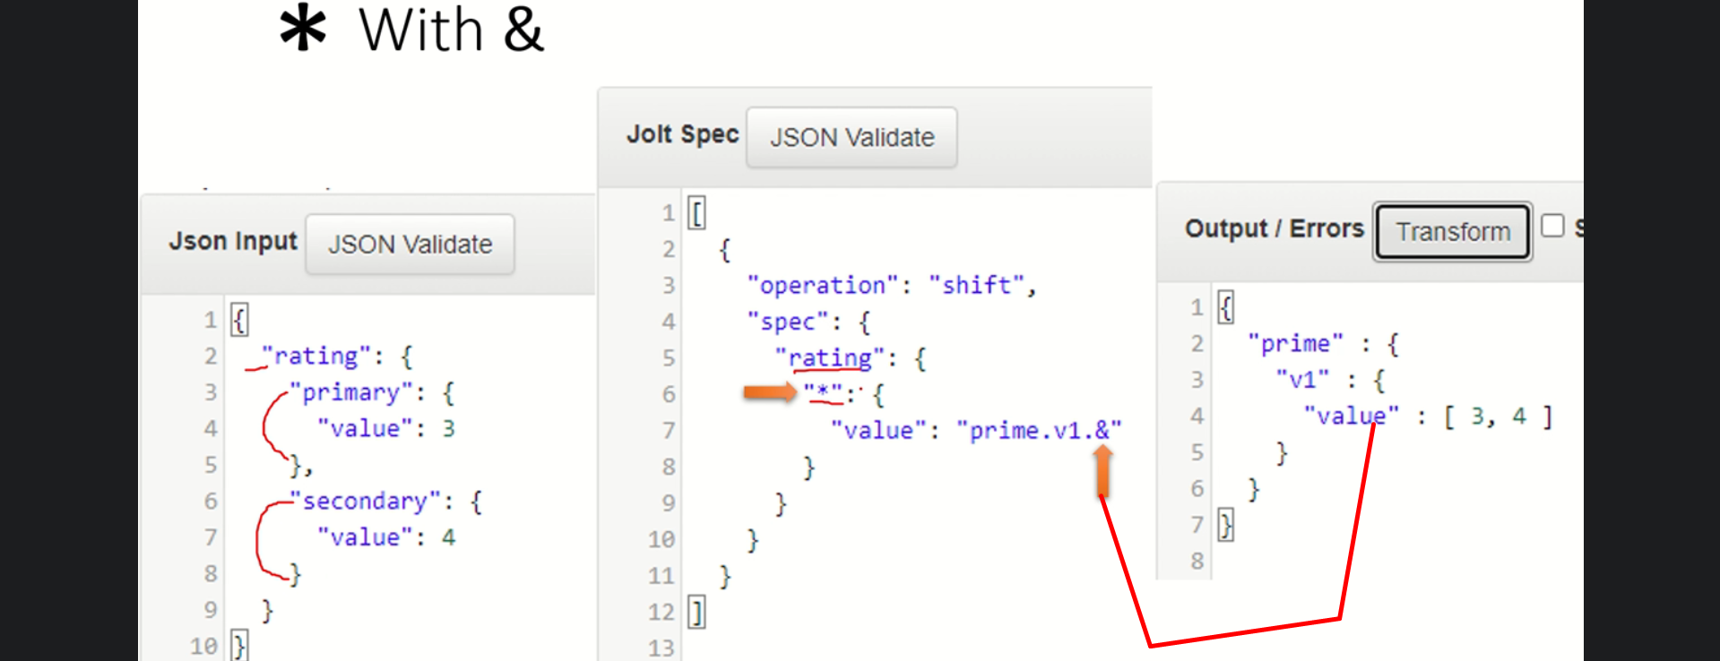
6. 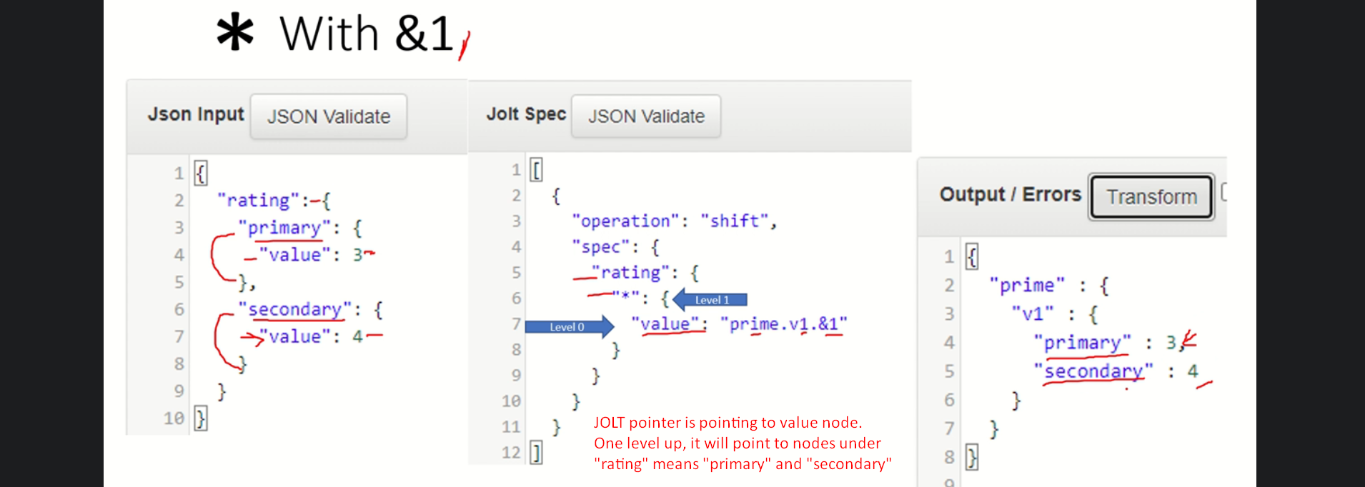
7. 